بسم الله الرحمن الرحيم

  Islamic University – Gaza  Faculty of Information Technology  Department of Software Development  Department of IT  Department of Multimedia and Web Development | الجامعة الإسلامية – غزة كلية تكنولوجيا المعلومات  قسم تطوير البرمجيات  قسم تكنولوجيا المعلومات  قسم الوسائط المتعددة وتطوير الويب

Basma
A digital archive documenting human stories, photos, and videos from Gaza.

بصمة
أرشيف رقمي يوثق القصص والصور والفيديوهات الإنسانية من غزة.
By

Ahlam Ragaa Abu Daib 220223260
Noora Asaad Ashour 220210399
Mona Ahmed Hijaze 220210969
Huda Jameel Salama 220222664

Supervised by
Dr. Ibrahim Saed Alfayoumi
A graduation project report submitted in partial
fulfillment of the requirements for the degree of
Bachelor of Information Technology

June/2026
Abstract

The war in Gaza has led to the loss and fragmentation of many human stories, memories, and personal experiences across different platforms, creating a challenge in preserving and documenting these narratives for future generations. Therefore, there is a need for a dedicated digital platform that can collect, preserve, and present such content in an organized and accessible manner.
The Basma project aims to develop a web-based platform for documenting and preserving stories, photographs, and videos related to the experiences of people affected by the war in Gaza.
The platform provides a user-friendly environment that enables users to browse content and share their own experiences while creating a digital archive that preserves collective memory and raises awareness of humanitarian issues.
The system was developed using modern web technologies. PHP and MySQL/MariaDB were used for the backend and database development, while HTML, CSS, Bootstrap, and JavaScript were used to create the user interface. An administrative dashboard was also implemented to manage stories, photos, videos, categories, and user submissions efficiently, A pragmatic Waterfall process was followed, consisting of requirements gathering, design (ERD and workflows), implementation, testing, and deployment on a local XAMPP stack.
The results demonstrate that the platform successfully provides an integrated digital environment for documenting, preserving, and managing human stories and multimedia content. The developed system achieved its main objectives by enabling organized access to stories, photographs, and videos and facilitating content sharing.
In addition, the platform has contributed to providing an interactive digital space that enables users to share and document their human experiences within an organized archive that is easy to access and benefit from.
In conclusion, Basma highlights the importance of digital platforms in preserving human experiences and collective memory. Future enhancements may include advanced search features and multilingual support to improve accessibility and user engagement.

ملخص الدراسة
أدت الحرب على غزة إلى ضياع العديد من القصص والذكريات والتجارب الشخصية عبر منصات مختلفة، مما خلق تحدياً في حفظ هذه الروايات وتوثيقها للأجيال القادمة. لذلك برزت الحاجة إلى منصة رقمية متخصصة تُمكن من جمع هذه القصص والمواد التوثيقية وحفظها بطريقة سهلة الوصول .
يهدف مشروع بصمة إلى تطوير أرشيف رقمي لتوثيق وحفظ القصص والصور ومقاطع الفيديو المرتبطة بتجارب الأفراد المتأثرين بالحرب في غزة. يهدف المنصة إلى توفير بيئة سهلة الاستخدام تُمكّن المستخدمين من تصفح المحتوى وإنشاء أرشيف رقمي يُسهم في حفظ الذاكرة الجماعية ونشر الوعي بالقضايا الإنسانية.
تم تطوير النظام باستخدام تقنيات الويب الحديثة حيث استخدمنا MySQL/MariaDB ولغة PHP الحديثة في بناء النظام وقاعدة البيانات، بالإضافة إلى باستخدام HTML وCSS وJavaScript وBootstrap لتطوير واجهات المستخدم. كما تم تصميم لوحة تحكم إدارية لإدارة القصص والصور والفيديوهات والتصنيفات والمشاركات المرسلة من المستخدمين، تم اتباع waterfall process، والتي تتكون من جمع المتطلبات والتصميم (مخطط علاقات الكيانات وسير العمل) والتنفيذ والاختبار والنشر على مجموعة XAMPP محلية.
أظهرت نتائج المشروع توفير بيئة رقمية متكاملة لتوثيق وحفظ المحتوى الإنساني وإدارته بكفاءة كما حققت الأهداف الأساسية للمشروع من خلال الوصول إلى القصص والصور ومقاطع الفيديو ومشاركة تجاربهم الإنسانية وتوثيقها ضمن أرشيف منظم يسهل الوصول إليه والاستفادة منه.
وفي الختام يبرز مشروع بصمة أهمية المنصات الرقمية في حفظ التجارب الإنسانية والذاكرة الجماعية، ويُوصى مستقبلاً بإضافة مزايا مثل البحث المتقدم ودعم لغات متعددة لتعزيز تجربة المستخدم وزيادة انتشار المنصة.

Inscriptions page

As we reflect on the past four years, we may recall that our greatest lessons were learned within the classroom. But this is a good reminder that learning doesn't end with a bachelor's degree. What we have experienced in these past years should remain etched in all our hearts, so the world may hear that the students of Gaza are a crown upon the heads of the entire world ….

عندما نفكر في السنوات الأربع الماضية، ربما نتذكر أن أعظم دروسنا جاءت من داخل حجرة الدراسة. لكنه تذكير جيد بأن التعلم لا يتوقف فقط لأننا حصلنا على درجة البكالوريوس وأن ما عشناه في هذه السنوات الأخيرة يجب أن يبقى محفور في قلوبنا جميعا ليسمع العالم أن طلاب غزة هم تاج على رؤوس العالم أجمع.

Dedication
To those who left this world before they had the chance to tell their stories…
To the souls who departed, leaving behind memories that still live in our hearts, and to the faces that disappeared from our sight but whose impact remains present in every corner of our lives.
To every mother who waited for a return that never came, and to every father who carried the burden of protecting his family through times filled with loss and uncertainty.
To every child who was forced to grow up too soon, learning lessons from war that no child should ever have to learn.
To those who lost their homes, their dreams, and their loved ones, yet never lost their strength, resilience, and hope.
To Gaza — not merely a place, but the story of a people who continue to write chapters of perseverance and survival against all odds.
And to every untold story, every silent tear, and every memory we feared would be forgotten…
We dedicate this work.
May these words preserve a small part of what time could not protect, and may these stories remain as witnesses to the lives of people who passed through these moments and left behind a mark that neither rubble nor time can erase.
To all of you, we dedicate “Basma” — a platform created to preserve memories, honor stories, and ensure that no voice is forgotten.

الإهداء
إلى الذين رحلوا قبل أن يرووا حكاياتهم كاملة…
إلى الأرواح التي غادرت تاركةً خلفها ذكرياتٍ لا تزال تسكن القلوب، وإلى الوجوه التي غيّبها الغياب وبقي أثرها حاضرًا في كل زاوية من حياتنا.
إلى كل أمٍّ انتظرت عودةً لم تأتِ، وإلى كل أبٍ حمل همّ عائلته في زمنٍ أثقلته الخسارات، وإلى كل طفلٍ كبر قبل أوانه، وتعلّم من الحرب ما لا ينبغي لطفل أن يتعلمه.
إلى الذين فقدوا بيوتهم، وأحلامهم، وأحبّتهم، لكنهم لم يفقدوا قدرتهم على الصمود.
إلى غزة… التي لم تكن يومًا مجرد مكان، بل كانت حكاية شعبٍ كامل، يكتب فصول بقائه بالأمل رغم كل ما مرّ به.
وإلى كل قصة لم تجد من يرويها، وكل دمعة لم تجد من يسمعها، وكل ذكرى خفنا أن يبتلعها النسيان…
نهدي هذا العمل.
لعلّ الكلمات تحفظ بعضًا مما عجز الزمن عن حفظه، ولعلّ الحكايات تبقى شاهدةً على أناسٍ مرّوا من هنا، وتركوا بصمةً لن يمحوها الركام، ولن يطويها النسيان.
إليكم جميعًا… نهدي "بصمة".

Acknowledgment
In the Name of Allah, the Most Gracious, the Most Merciful
Before all else, we thank Allah Almighty, whose mercy and guidance illuminated our path and granted us the strength to continue when the journey seemed impossible. Through His blessings, we were able to transform an idea born amidst hardship into a project that carries the voices, memories, and stories of a people who refused to be forgotten.
We extend our deepest gratitude to our supervisor Dr. Ibrahim Saed Alfayoumi, whose wisdom, encouragement, and unwavering support inspired us throughout every stage of this project. His guidance was not only academic but also a source of motivation during some of the most challenging moments of our journey.
To the professors of the College of Information Technology at the Islamic University of Gaza, thank you for the knowledge, dedication, and values you have instilled in us. Your efforts have shaped who we are today and prepared us to face challenges with confidence and determination.
To our families, words can never fully express our gratitude. Thank you for your endless patience, sacrifices, prayers, and belief in us. During difficult days and uncertain times, you remained our source of comfort, hope, and strength.
To our friends and colleagues, thank you for every encouraging word, every helping hand, and every moment of support that made this journey lighter.
Finally, this project is dedicated to the people whose stories inspired its creation. To every individual who lived through hardship, loss, displacement, fear, and resilience—your experiences gave meaning and purpose to Basma. We hope this work contributes, even in a small way, to preserving memories that deserve to live on and stories that deserve to be heard.
With sincere appreciation and gratitude
The Basma Team

الشكر والتقدير
بسم الله الرحمن الرحيم
الحمد لله أولًا وآخرًا، ظاهرًا وباطنًا، الذي أنار لنا الطريق، ومنحنا القوة لنواصل المسير رغم كل الصعوبات والتحديات. فبفضله وحده تحولت فكرة وُلدت في زمنٍ استثنائي إلى مشروع يحمل قصصًا وذكرياتٍ وأصواتًا نؤمن بأنها تستحق أن تبقى حية في الذاكرة.
نتقدم بخالص الشكر وعظيم الامتنان إلى مشرف مشروعنا الدكتور إبراهيم سعيد الفيومي، الذي لم يبخل علينا بعلمه وتوجيهه ودعمه طوال مراحل العمل. فقد كان لكلماته ونصائحه وتشجيعه أثرٌ بالغ في تجاوز العقبات والوصول بهذا المشروع إلى صورته النهائية.
كما نتوجه بالشكر إلى أساتذتنا الكرام في كلية تكنولوجيا المعلومات بالجامعة الإسلامية بغزة، الذين غرسوا فينا حب العلم، ومنحونا المعرفة والخبرة التي كانت أساسًا لما وصلنا إليه اليوم.
أما الشكر الأكبر، فهو لعائلاتنا العزيزة؛ لآبائنا وأمهاتنا الذين كانوا السند الحقيقي في كل خطوة، ولأسرنا التي منحتنا الحب والدعاء والصبر والثقة عندما كانت الظروف أقسى مما تُوصفه الكلمات..
لولا دعمكم وإيمانكم بنا لما كان هذا الإنجاز ممكنًا.
كما نشكر أصدقاءنا وزملاءنا وكل من مدّ لنا يد العون، أو قدم كلمة تشجيع، أو شاركنا لحظة دعم خلال رحلتنا الأكاديمية.
وأخيرًا، نتوجه بالشكر لكل إنسان كانت قصته سببًا في ولادة هذا المشروع. لكل من عاش الخوف، أو النزوح، أو الفقد، أو الألم، ثم واصل طريقه رغم كل شيء. أنتم لستم مجرد قصص نرويها، بل أنتم سبب وجود هذا العمل وروحه الحقيقية.
نسأل الله أن يكون هذا المشروع شاهدًا على حكايات تستحق أن تُروى، وأن يبقى أثرها حاضرًا في الذاكرة، تمامًا كما أراد له اسم “بصمة” أن يكون.
فريق بصمة

Table of Contents
Automatic Table of Contents
Dedication 4
Acknowledgment 5
Table of Contents 6
List of Tables 7
List of Figures 8
List of Abbreviations 9
Chapter 1
Introduction 1
Chapter 1
Introduction 2
1.1 Problem Statement 2
1.2 Objectives 2
1.2.1 Main Objective 2
1.2.2 Sub Objectives 2
1.3 Scope and Limitations 3
1.4 Importance of the project 3
1.5 Tables 3
1.6 Figures 4
Chapter 2
Related Works 5
Chapter 3
Methodology 6
Chapter #
Chapter Name 9
Chapter #
Chapter Name 10
Chapter #
Chapter Name 11
Chapter #
Conclusions and future works 12
References 13
Appendix 1: Information on Appendices 15

List of Tables
Table (1): Number of Laptop vs. Mobile Users (2021-2023) 3
Table (2): Test cases runner customization parameters. 3

List of Figures
Figure (1): Average time on site (mobile vs desktop) 5

List of Abbreviations

CUT | Class Under Test
RTS | Regression Test Selection
SUT | System Under Test
TDD | Test Driven Development

*Note: Sort Alphabetically

Chapter 1
Introduction

Chapter 1
Introduction
Stories are among the most valuable forms of human memory. They preserve experiences, emotions, and events that shape individual and collective identities. In regions affected by conflict, many personal stories remain undocumented and risk being forgotten over time. Gaza, with its ongoing humanitarian challenges, contains countless stories of suffering, resilience, hope, and survival that deserve to be preserved and shared with the world.
"Basma" is a digital documentary platform designed to collect, preserve, and present authentic stories and multimedia content from Gaza. The platform serves as a digital archive that enables users to access written testimonies, photographs, videos, animations, interactive maps, and statistical information related to the lives of Palestinians in Gaza.
The platform aims to provide a reliable space where individuals can share their experiences and where researchers, journalists, and future generations can access documented content. Through modern web technologies and a human-centered approach, Basma contributes to preserving Palestinian memory and delivering the voices of Gaza to local and international audiences.

Problem Statement
Many stories, memories, and personal experiences from Gaza remain undocumented or scattered across different media sources. The absence of a centralized platform dedicated to preserving and organizing these stories may result in the loss of valuable historical and humanitarian records. Furthermore, limited accessibility to authentic testimonies reduces global awareness of the daily realities faced by the people of Gaza.

1.2 Objectives
1.2.1 Main Objective
To develop a digital documentary platform that preserves, organizes, and publishes authentic stories and multimedia content from Gaza, ensuring that the voices of its people are documented and accessible to future generations.

1.2.2 Sub Objectives
- Document real stories and personal testimonies from Gaza.
- Preserve photographs, videos, and multimedia materials in a structured digital archive.
- Provide users with easy access to documentary content through an organized platform.
- Present interactive maps and statistical information to support understanding of events.
- Highlight stories of resilience, courage, and daily life in Gaza.
- Increase local and international awareness of humanitarian issues through authentic content.
- Preserve Palestinian memory using modern digital technologies.

1.3 Scope and Limitations

The scope of the Basma platform is to provide a digital environment for documenting, storing, and sharing stories and multimedia content related to Gaza. The platform allows users to browse and access written testimonies, photographs, videos, animations, maps, and statistical information through an organized and user-friendly interface.
However, the project is limited to content associated with Gaza and depends on internet availability and user participation. Additionally, the authenticity of submitted content relies on administrative review and verification procedures before publication.

1.4 Importance of the project

Basma contributes to preserving Palestinian memory by creating a secure and organized digital archive for stories and multimedia content from Gaza. The platform supports researchers, journalists, students, and humanitarian organizations by providing access to authentic information and personal experiences. Moreover, it helps raise global awareness about humanitarian issues while ensuring that future generations can learn from and remember the stories of the Palestinian people.

1.5 Tables
The caption: should be included in the table as the first row formatted like this:
Table (Chapter number. Table number): The title of the table (Time New Romans, font size 12.)
Example:
Table (1): Number of Laptop vs. Mobile Users (2021-2023)
Year | Laptop Users | Mobile Users
2021 | - | -
2022 | - | -
2023 | - | -
Source: [Insert Source of Data]
Table (2): Test cases runner customization parameters.
Parameter | Description
TEST_RUNNER_THREADS | The number of parallel threads that can run test.

1.6 Figures
- In text: Figure 1
- The caption: should be located under the figure formatted like this:
Figure (1): Average time on site (mobile vs desktop)
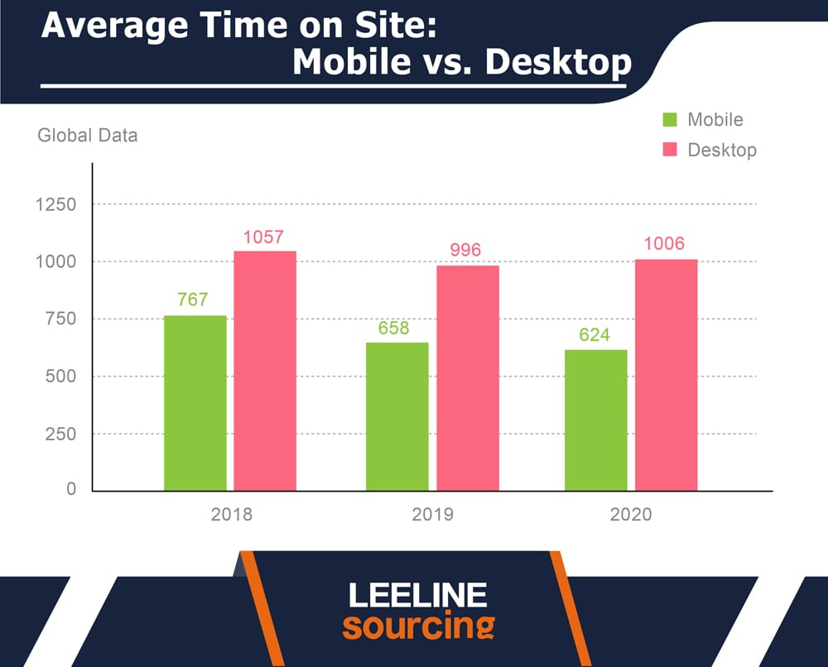

Chapter 2
Related Works
It should include reviews of previous work by others that are relevant to the project. A review does NOT mean reproducing in detailed material given in textbooks, reports and papers. It DOES mean summarizing the information (with pointing to the references) so that a reader is informed of where to look for the information.
Everything that you write must be your own words and you must cite other people using references.
Summarize the differences between your project and other related reviewed projects and show how your project is different.

Chapter 3
Methodology
The Methodology chapter should describe how you carried out your project. This includes the techniques, tools, and procedures you used to gather and analyze data, develop your product, or conduct your research. Be clear and detailed so that someone else could replicate your work.
You should mention the software development methodology you used in the Methodology chapter. This is a crucial aspect of your project, as it outlines the overall approach and process you followed to develop the software.

Be sure to:
- Name the methodology: Clearly state which methodology you used (e.g., Agile, Scrum, Waterfall).
- Explain why you chose it: Briefly justify your choice, highlighting how it aligned with your project's goals, constraints, and requirements.
- Describe the key practices and phases: Outline the main steps and activities involved in the methodology, and how you implemented them in your project.
- Discuss any adaptations or modifications: If you made any changes to the standard methodology, explain why and how these changes impacted your development process.
Remember that the Methodology chapter should be detailed enough for someone else to understand and potentially replicate your approach. By clearly articulating your software development methodology, you demonstrate a strong understanding of the development process and enhance the credibility of your project.
If your project is a multimedia production, the Methodology chapter should still describe the process you followed, but the focus will shift towards the creative and technical aspects of multimedia production.

The Methodology chapter should include these sections:
- Name of the methodology: Clearly state which methodology was used (e.g., Agile, Scrum, Waterfall).
- Rationale for choosing the methodology: Briefly justify the choice, highlighting how it aligned with the project's goals, constraints, and requirements.
- Key practices and phases of the methodology: Outline the main steps and activities involved in the methodology and how they were implemented in the project.
- Adaptations or modifications to the standard methodology: Explain any changes made to the standard methodology, why they were made, and how these changes impacted the development process.
- Tools and Equipment: This section should list the specific software, hardware, or other tools used during the project. For software projects, this might include programming languages, IDEs, libraries, and frameworks. For multimedia projects, it could include cameras, microphones, editing software, and animation tools.
- Timetable: This section could outline the project's timeline, including key milestones, deadlines, and the duration of each phase. This demonstrates project planning and time management skills.
- Team Management
  - Team Structure and Roles: Explain how your team was organized and the roles and responsibilities of each team member.
  - Communication and Collaboration Tools: Describe the tools and methods you used to communicate and collaborate with your team members (e.g., project management software, version control systems, communication platforms).
  - Conflict Resolution Strategies: Briefly discuss how your team handled disagreements or challenges that arose during the project.
  - Teamwork and Delegation: Explain how tasks were delegated and how the team worked together to achieve the project's goals.
Remember that these sections should be described clearly and in detail so that the approach can be understood and potentially replicated by someone else.
Remember to adapt these sections to the specific requirements of your project and the expectations of your department or supervisor.

Chapter #
Chapter Name
(include chapters as needed in your project)

After the methodology chapter, you have to include several chapters depending on your project.

For a software development project, you may include the following chapters:
- Requirements Analysis: Detailed description of the functional and non-functional requirements gathered and prioritized.
- System Design: Description of the overall architecture, design patterns, and key components of the software solution.
- Implementation and Coding: Details about the programming languages, tools, and libraries used, as well as coding standards followed.
- Testing and Evaluation: Description of the testing strategy, test cases, and results, including unit testing, integration testing, and user acceptance testing.
- Deployment and Maintenance: Explanation of how the software will be deployed, monitored, and maintained.
- User Manual (if applicable): Instructions on how to install, use, and troubleshoot the software.
Remember that some of these chapters might be combined or split depending on your specific project and its requirements.

For a multimedia production graduation project like creating a short, animated film, you could include chapters such as:
- Pre-Production: This would detail the initial stages of your project, including concept development, scriptwriting, storyboarding, and character design.
- Production: This chapter would describe the actual creation of your film, including digital drawing, animation, audio recording, and music composition.
- Post-Production: This would cover the final stages of your project, such as video editing, sound editing, and visual effects.
- Testing and Evaluation: This chapter could describe how you gathered feedback on your film and used it to improve the final product.

Discuss with your supervisor what are the chapters that you may include in your report

Chapter #
Chapter Name

Chapter #
Chapter Name

Chapter #
Conclusions and future works
Conclusions

The Conclusions chapter should encapsulate the key findings and outcomes of your IT project, emphasizing their significance and relevance to the field. It should directly address the objectives outlined in the introduction, providing a clear assessment of how well they were achieved. This chapter should highlight the successful implementation of your project, the functionality of the developed system or application, and the potential impact it can have on the IT industry or relevant sector. By summarizing your results and reflecting on your initial goals, you demonstrate the successful completion of your project and its contribution to the advancement of IT knowledge and practice.

Future Work

The Future Work chapter should explore potential avenues for further development based on the outcomes of your project. It should identify any limitations encountered during the project and suggest ways to address them in future work. This chapter might include recommendations for enhancements, scalability, or integration with other systems. You could also propose exploring new technologies or methodologies that could build upon your project's foundation. By outlining potential future directions, you highlight the long-term value and relevance of your research, opening doors for continued innovation and exploration in the IT field.

References
This has the following purposes:
- To acknowledge the source of material being used.
- To tell the reader where the confirmation of statements that you have made can be found.
- To tell the reader where a more extensive or more detailed discussion of the subject (or related subject) can be found.
Use IEEE style for citation / references. Check the video https://youtu.be/iguguW1MXZ4?si=fzgb-69zMvDSYn_Y to see how to manage your references in IEEE style
Example:
Here's an example of a numbered IEEE style citation and reference:
In-text Citation:
"As demonstrated in, self-attentive sequential recommendation can effectively model user preferences."
Reference List Entry:
W.-C. Kang and J. McAuley, "Self-attentive sequential recommendation," in 2018 IEEE International Conference on Data Mining (ICDM). IEEE, 2018, pp. 197-206.
Key Points:
- The in-text citation uses a number in square brackets to refer to the corresponding reference list entry.
- The reference list is ordered numerically, and each entry starts with its reference number in square brackets.
- The rest of the reference entry follows the standard IEEE format, including author names, title, publication venue, year, and page numbers.
Remember that while IEEE style is primarily author-date based, it allows for a numbered style option. Check with your department or supervisor to confirm which format they prefer.

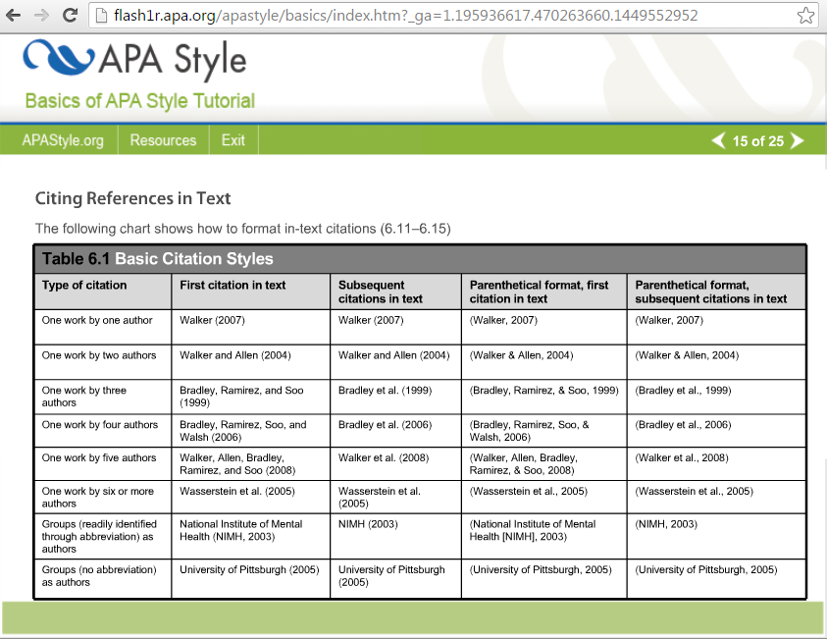
Appendix 1: Information on Appendices
Appendices may be provided to include further details of results, mathematical derivations, certain illustrative parts of program code (e.g. class interfaces), user documentation, log of project milestones. In particular, if there are technical details of the work done that might be useful to others who wish to build on this work, but that are not sufficiently important to the project as a whole to justify being discussed in the main body of the thesis, then they should be included as appendices.
There is no expectation that the examiners should read the appendices as part of the assessment process. Hence, it is important that any material which will be significant to judging the quality of the thesis or of the project as a whole should be in the main body of the thesis, and not in appendices.

